The Commissioning Service
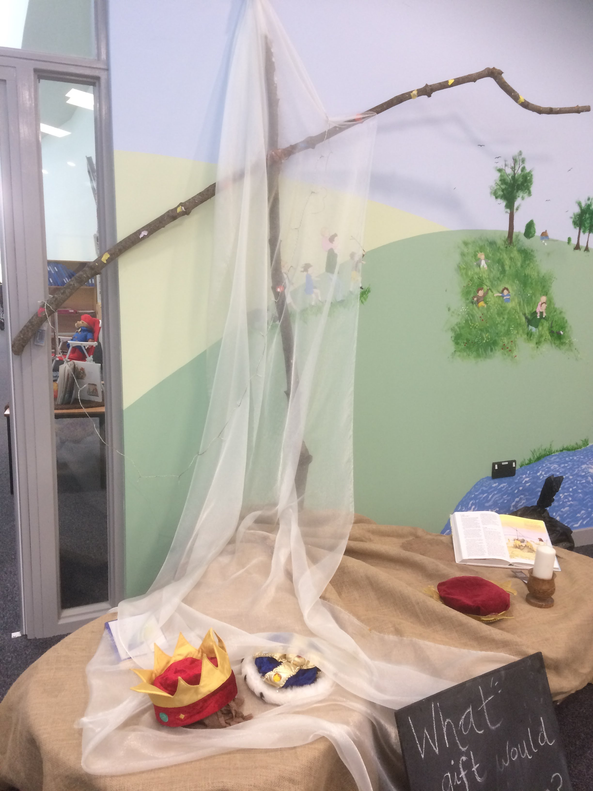

Notes on the Service for use when commissioning a new Head teacher. A similar service is available affirming a head teacher who is already in post.

Introduction
The aim of this short service is to bless and ‘commission’ the new headteacher to this very important role in the school community.

The relationship between education and the Church goes back to the dawn of Christianity itself. Our Lord was a teacher and He had special words to say about the role of children in the Kingdom. Closer to our time, King Alfred could be said to be the founder of English education with the founding of schools and the translation of books into English. Nearer our time, the eighteenth and nineteenth centuries saw a great outpouring of effort as the Church founded thousands of Church Schools for the education of its young people. It wasn’t until 1870 that the state took on responsibility for the education of its young. Local Education Authorities were founded in 1905.

The 1944 Education Act saw Church Schools making a choice between being aided or controlled. Voluntary Controlled schools are closer to their local authority. Aided schools have a majority of foundation Governors and, although part of the maintained sector, have a closer allegiance to the Church. Whether Voluntary Controlled or Voluntary Aided, Church Schools are part of the same family and have a distinctive nature rooted in the Gospel. In the Diocese of Bath and Wells there are over 33,000 children in Church of England schools. This means that over 50% of children up to the age of eleven are taught in Church of England schools. The percentage of those over eleven is thirteen per cent.

If the school is part of an Academy Trust, it is important that this is also acknowledged and celebrated as part of the service. Representatives from the Trust can be present, take part and perhaps offer a gift. If not, the LA may be invited and included.

All schools are deeply moral places. These services are aimed not only at the Church “family” of schools but at all schools if they feel that a public act of introduction or affirmation is appropriate. These services are rooted in the Anglican tradition but that, in turn, is rooted in the Judeo-Christian tradition that lies at, or near, the heart of all education in our country. These services are offered in that spirit.

This service is both a celebration and a commitment. The commitment is not only on the part of the new Headteacher, but on the part of all within the school community to support the headteacher as they take on their new role.

The service aims to help the school community present or affirm its head teacher to the wider (worship) community. As such, they will probably take place in the parish church where the new head is “presented” to the wider community. In primary schools, where the parish community is relatively obvious, this may be easy. In the case of secondary schools the link between the school and its constituency may not be so obvious because it is wider and, perhaps, diffuse. It could be said that in these cases that there is even more need to make the connection between the school and its parish constituency.

Within the Diocese of Bath and Wells, in the Education Team, a School Adviser would be more than happy to discuss any aspect of these services and offer advice and help on how they can be adapted for use in your community.

This service is a template, or model, for you to use and amend as you would like to. Please make it personal to your Headteacher, your school and your community, so that it can be a memorable occasion of celebration for everyone.

The Commissioning Service

Introduction
The aim of the Commissioning service is to present a new head teacher to the wider community. This service also aims to be flexible so that it can stand alone or be incorporated into a Family Eucharist or other service. This could be an Easter, Christmas or Harvest Service or a Service in which the Vision and Values of the school are relaunched. The Service aims to involve all the members of the schools’ community: the staff, the pupils, the parents, the Governors, The Trust (if applicable) and the wider community, including the church and parish council. Some schools have welcomed other schools within their area and their primary or secondary schools. If the school has an ‘Open the Book’ team or other regular visitors, they may also be invited. The Diocese would like to attend and present a small gift to the Headteacher. The Local Authority may also like to be invited. This service can be symbolic of partnerships and can also serve other purposes depending on the current context of the school.

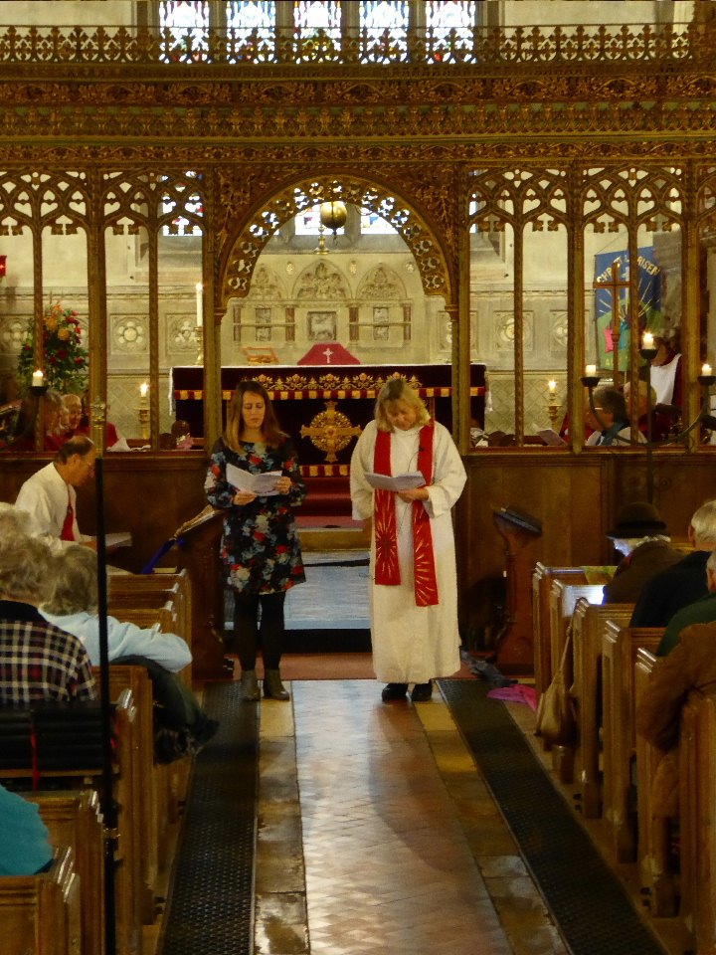

There are a number of things to consider:

- Will the service be in the local church or at school (inside or outside)?
- What is the most suitable time and date?
- Who would the headteacher, governors, MAT, church community like to invite? The service can have many invitees as above, or be much smaller in scale.
- Will the service be part of our usual collective worship, be a special service in its own right, or be part of another service such as Easter, a ‘Vision and Values’ service, Thank you Service, or something else?
- How will we adapt the service template or do we have another idea of how we would like to commission our headteacher? It is important that the service is right for your school. It can take any format and this template is designed to be flexible and adaptable to meet your purpose and needs.
- Are there ways in which the children and others in the local community can be involved to ensure it is unique to the school and a celebration of both the new headteacher and perhaps the journey ahead for the school?
- Will anyone take photographs?
- Will there be refreshments afterwards?
- Will there be local media, school newsletter, or other communication before or after the event?

