Safeguarding Leadership Pathway

Participant Workbook

  - Name:
  - Role:
  - Diocese/Cathedral:
  - October 2023

- Introduction
As a Diocese we recognise the importance leaders play in creating and maintaining a safe environment for all, in whatever way they support the work of the Church. We are committed to enabling leaders to develop and maintain the necessary knowledge, attitude, behaviours, and skills to safeguard and protect children, young people, and vulnerable adults.

The national Safeguarding Learning and Development Framework sets out the vision for safeguarding learning to ensure that all Church officers develop skills and knowledge in safeguarding to an appropriate level.

This pathway supports our Diocesan vision. It is essential that we understand safeguarding as a theological imperative, rooted in the nature and love of God, and outworking in basic commitments to giving equal worth to all.

The Church of England has committed to developing a set of National Safeguarding Standards as part of a quality assurance framework. The quality assurance framework currently under development will be a mechanism for:
- Asking and answering the question: How well are we doing this and what is the difference / outcome being achieved?
- Analysing the answers to this question to gain learning and deepen organisational safeguarding understanding and expertise.
- Using that learned expertise to drive systematic change and continuous improvement in both the quality and impact of the activity, and to increase our knowledge and understanding of the evolving nature of Church-based abuse.

This learning pathway has been built around these National Safeguarding Standards:

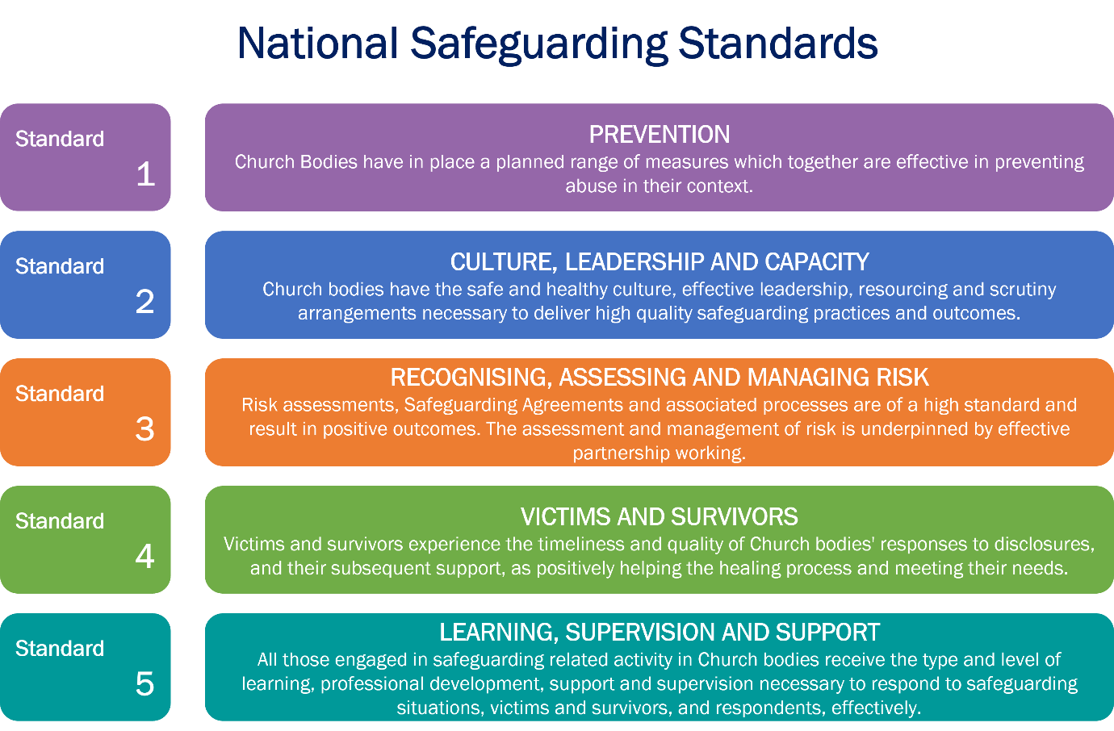
2. Learning Outcomes of this pathway
This pathway is intended to be transformational. Once people have completed it, the aim is that they are in some way different from the people they were at the start. The aim is that participants reflect deeply on their own values and beliefs and integrate these with the values and beliefs underpinning good safeguarding behaviour. The idea is that good safeguarding behaviour can then flow from an inner motivation, rather than be experienced as an external process to be followed under duress.
By the end of this pathway participants will:
  - Understand how safeguarding concerns and abuse can be prevented within their context.
  - Understand how healthy culture, and safe and effective leadership, shape Christian communities that are healthy, safe, and have the capacity to deliver high quality safeguarding practices.
  - Recognise when risk assessment and management processes are required, understanding when, why and how they must be used.
  - Understand more of the impact that abuse and trauma have on individuals’ lives, relationships, and interactions in a community setting, leading to better responses to victims and survivors.
  - Evaluate their learning and translate this into an individual plan of action that will improve their safeguarding practice and responses.

3. Structure of this pathway
Please note: It is important that you have completed the Basic Awareness and Foundation level modules prior to attending this Leadership pathway.
This pathway aims to encourage a process of reflective learning involving individual tasks and groupwork. The pathway consists of two sessions with an evaluation task to be undertaken after session two. This Pathway reflects our National Safeguarding Standards creating dedicated space to explore or culture, values, belief, and responses to safeguarding within our Church.
- The focus of the first session is on standards one and two – 1. prevention, and 2. culture, leadership, and capacity. Creating environments in which everyone is safe and can flourish is fundamental to our purpose as God’s Church. Building safer, healthier cultures is all about modelling attitudes and behaviours to those around us to achieve this purpose. To effectively create safer places, we must be prepared to look at our cultures – do they support this mission and vision? How do we know that we are both safe and healthy?
- The focus of the second session is on standards three and four – 3. recognising, assessing, and managing risk, and 4. victims and survivors. In exploring how to respond effectively to safeguarding concerns and the people involved within them the aim is to get beyond mere consideration of process. This session builds upon discussions around the importance of healthy culture, leadership, and capacity as the foundation of good safeguarding practices and the role that they play in prevention.
- The focus of the evaluation task is on standard five – 5. learning, supervision, and support.

The leadership pathway consists of one course with two sessions, held one week apart, each with pre-work to be completed before them. There is an evaluation task to be completed after the final session. All elements of the pathway must be completed for you to be issued with your certificate of completion.

Please note: The pre-course work for the first session must be returned at least 1 week before Session 1.

4. Session preparation

Prior to each session there is preparation work to be completed; the flow-chart below summarises the pathway and the pre-work required. You are invited to undertake the tasks at your convenience however please ensure these are completed prior to the session for which they are required.

Please note: If you do not submit your answers within the period stated or if your answers indicate that no real thought and reflection has taken place, we will ask you to review your submission before inviting you to join the rest of the pathway.

- Participants will receive their workbooks as soon as they are booked on to the course. This enables them time to read and complete the preparation work.
- The pre-course work for the first session must be returned at least 1 week before Session 1.
- The evaluation task needs to be completed six weeks after session 2 to appropriately evaluate the outcomes of the course, the learning taken from it and how this learning will be put into practice. The evaluation needs to be submitted to the facilitators.
- Session 2 is a 90-minute session focused on recognising, assessing, and managing risk and on victims and survivors, using a scenario which focuses on how healthy culture and leadership can prevent safeguarding concerns from escalating.
- Before session 2 participants are required to:
  - Identify one thing which has influenced their responses, values, and beliefs regarding safeguarding.
  - Respond to questions focusing on risk.
  - Read the scenario setting and first scene of the case study.
- Session 1 is a 90-minute session comprising three exercises focusing on prevention and culture, leadership, and capacity.

Session 1
Session one focuses on the standards 1. prevention, and 2. culture, leadership, and capacity. This session will draw on reflections from the preparation work you are about to undertake and your own experiences of healthy cultures. The session places focus upon creating environments in which everyone is safe and can flourish citing this as fundamental to our purpose as God’s Church.

Preparation for Session 1

There are three tasks.

Reflect on each of six aspects depicted on the ‘Culture Conversation Cube’.

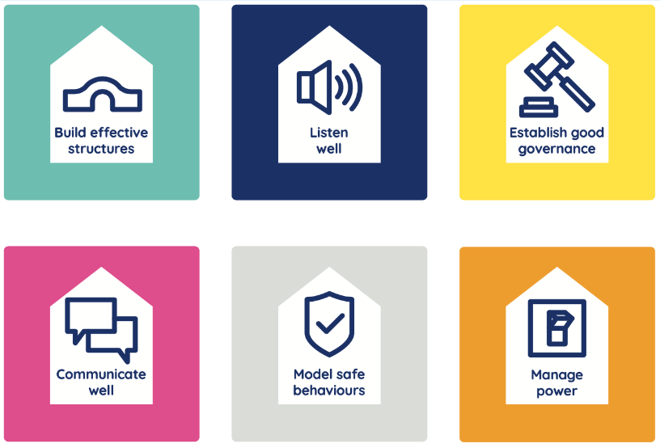
Take a few minutes to reflect on each aspect labelled on the culture cube. What attitudes, behaviours, and values are present within your church? Note your thoughts on the table below – we have given you a prompt on each to start you thinking.
NB The Code of Safer Working Practice and the Guidelines for the Professional Conduct of Clergy may assist in your responses regarding the ‘model safe behaviours’ aspect.

Reflections on the ‘Culture Conversation Cube’:
Build effective structures  (What structures, procedures, protocols and good practice do you have in place?) | Listen well  (How do you listen to the views and concerns of those inside and outside the church?)
Establish good governance  (In what ways does your church/setting hold people to account and challenge behaviours?) | Communicate well  (How do you communicate with everyone?)
Model safe behaviours  (In what ways do church leaders model safe behaviours and ways of working?) | Manage power  (How is power and authority exercised and your church? Is it open to challenge?)

Colour or mark the matrix below to help you identify areas of strength and development.

 | Poor | Improving | Good | Excellent

Build effective structures

Listen well

Establish good governance

Communicate well

Manage power

Model safe behaviour

- Write a reflection in response to each of the questions below. There is no required word count or structure to your reflection but 250-300 words per question is a useful guide.
- Your reflection can also be informed by your experience of attending the last Leadership Pathway (if previously completed) or reading of the recommended texts (see page 17) – however this reading is optional.

Question 1: If your Church epitomised a healthy culture, what would you see, hear, feel, and experience as a member?

Question 2: How could your church, its culture, and the way it is experienced contribute to the prevention of safeguarding issues?

The Social GGRRAAACCEEESSS. diagram

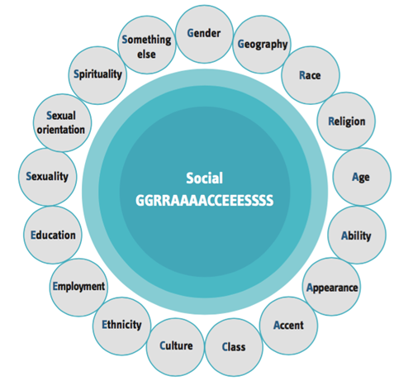

Watch and / or read the resources on the Social GGRRAAACCEEESSS.

A 30-minute video can be found on the Church of England’s Safeguarding Portal. You will need to create or log in to your account to view the video.

https://safeguardingtraining.cofeportal.org/course/view.php?id=436

Links to the written materials are also available below:

Social GGRRAAACCEEESSS and Safeguarding Document

Social GGRRAAACCEEESSS and Safeguarding easier reading version

When exploring these resources, you might want to consider the following questions:
  - What factors from a person’s own life experiences, history and characteristics could impact on their beliefs, values, and emotions?
- How does this impact the way we respond?
- How does this impact how we are perceived?

These reflections are for your own learning and you do not need to submit feedback on this question.

You should submit your workbook with your completed Task 1 and 2 answers to:
training.safeguarding@bathwells.anglican.org no later than one week before Session 1, so that the facilitators can prepare for the discussion that forms the basis of the session.
Once you have completed the pre-course tasks in your handbook, you can choose the best way to submit your responses:
- email a copy of your handbook back to this training team
- copy and paste your responses into the body of an email and send that to the team
- take a photo of your hand-written responses and email those back to the team

If you would prefer an alternative method to emailing your responses, please contact us to discuss. We may be able to take your reflections verbally.
Please note: If you do not submit your answers within the period stated or if your answers indicate that no real thought and reflection has taken place, we will ask you to review your submission before inviting you to join the rest of the pathway.

Session 2

Session 2 focuses on the standards 3. recognising, assessing, and 4. managing risk and victims and survivors. It draws upon the discussions from session one around healthy culture, leadership and capacity using a scenario that emphasises how safeguarding concerns can be prevented from escalating.

Preparation for Session 2

There are three tasks. You will not need to submit any written feedback prior to session 2.
- Identify: Who has influenced your values and beliefs with regards to safeguarding?
Please identify someone past or present, who by their words and actions has influenced your understanding of safeguarding.
We ask that you come prepared to this session being able to share who has influenced you and explore how this has informed your responses, values, and beliefs regarding safeguarding.
Examples:
Thomas Jefferson / Mahatma Gandhi “The true measure of any society can be found in how it treats its most vulnerable members.”
“Speak up for those who cannot speak for themselves, for the rights of all who are destitute. Speak up and judge fairly; defend the rights of the poor and needy’ (Proverbs 31:8).
Proverb- “It takes a village to raise a child”.
Mark 12:30-31 (ESV) And you shall love the Lord your God with all your heart and with all your soul and with all your mind and with all your strength.’ The second is this: ‘You shall love your neighbour as yourself.’ There is no other commandment greater than these.”

- Reflect on the questions on the next page, which focus our minds on recognising, assessing, and managing risk. You do not need to email your notes to the training team.

Question 1: Who has influenced and therefore underpins your values and beliefs regarding safeguarding?

Question 2: How confident are you in recognising and managing risk on a scale of 0 – 10 (where 0 is not at all confident and 10 is extremely confident)?
What supports your score?

Question 3: What safeguarding risks exist in your own context – what are we worried about?
    - What challenges have you experienced in managing a known safeguarding risk?
    - How are/should these risks be managed/mitigated – what’s working well and what can we do?

- Read the setting and first scene of the case study below:

Setting:
- Place: mid-size (≈15,000 people) market town in agricultural county. No other towns nearby, all villages and farms. Anytown is therefore the hub for services, shopping, education, and leisure activities for a large and mostly rural surrounding area.
- Church: St Ethelburga’s. Mid-size (≈80 people) church in the middle of Anytown with a small number of young people in the congregation, plus a larger number of young people who ‘hang around’ the church but do not attend. Anytown does not have a youth club or anything similar. Several the young ‘hangers on’ have said they would attend a youth group if the church ran one.

Main characters:
- Matthew, 35: Vicar. Has been at St Ethelburga’s for seven years, his first incumbency. The congregation had dwindled under the previous incumbent who had been there for 25 years until retirement, but Matthew has slowly been bringing people back since he arrived. Matthew would love to run a youth group himself but does not have time with his other commitments.
- Emma, 33. Emma is Matthew’s wife. Emma with support from Kate runs Sunday School / Messy Church, which has been successful.
- Kate, 27: Came back to the church following Matthew’s arrival. Kate runs a mother’s and toddler’s drop-in group which meets at the church on weekday mornings. Kate also runs Sunday and Messy play with Emma.
- Clive, 67. Retired Probation Officer. Clive is the Parish Safeguarding Officer, having been appointed soon after Matthew’s arrival. Prior to Clive, the parish had not had a PSO for several years. Clive has worked closely with Matthew, Emma, Kate, and others to get the parish’s safeguarding back ‘on track’ from where it was when he took over.
- Christopher, 29: Single. Accountant. Very friendly, open. Went to Bible college after school, has done some overseas mission work. Joined St Ethelburga’s three months ago, lives out of town. Gives the impression of being ‘in tune’ with the young people in the church; has similar musical and fashion tastes, etc.

Scene 1:
Christopher has been going to every service at St Ethelburga’s since he arrived three months ago. He is popular, energetic, and seems very devout. He has been helping at tea and coffee mornings and has said he would love to join the worship band which plays at the ‘contemporary’ service once a month (he plays guitar). He has been getting to know the young people in the church, chatting with them after the service, and knows the names of some of the other young people who ‘hang around’ the church but do not attend services. He has also got to know the wider church and appears to just be being very friendly and engaging with everyone.

Consolidation and Evaluation

The history and experience of evaluation in “safeguarding training” – across all sectors, not just the Church - is that it tends to focus on the immediate self-reported capturing of people’s experience of the session itself. The limitation of this is that we just do not know if such training is having any impact – do people just “attend” the training event, tick that box, and continue as before?

The evaluation that really matters is whether the “learning experience” has affected someone’s beliefs, values and understanding at a deep level so that there is a change in the person’s behaviours. They now do things not because they must do something, but because they really want to exhibit those behaviours. This is called “second order” change – when people do things because there is an inner motivation.

So, if this “learning experience” has been effective, a participant will, in some respects, be a different person from the one that started the experience.

The purpose of evaluation, then, is to try to find out if any difference has indeed been achieved.
At the beginning of the workbook, we set out the learning outcomes the programme is designed to deliver, and they are repeated here.
By the end of this pathway participants will:
  - Understand how safeguarding concerns and abuse can be prevented within their context.
  - Understand how healthy culture and safe and effective leadership shape Christian communities that are healthy, safe, and have the capacity to deliver high quality safeguarding practices.
  - Recognise when risk assessment and management processes are required, understanding when, why and how they must be used.
  - Understand more of the impact that abuse and trauma have on individuals’ lives, relationships, and interactions in a community setting, leading to better responses to victims and survivors.
  - Evaluate their learning and translate this into an individual plan of action that will improve their safeguarding practice and responses.

The evaluation task.

If this learning programme has been successful, there will be evidence of the above behaviours which others will be able to see. The evaluation task, therefore, is:
Six weeks after the second session, complete the self-reflection below, on how you have applied the learning from this pathway and complete an action plan (3-4 items) showing how you will integrate your learning into your safeguarding practices. Your self-reflection and action plan should be submitted to the pathway facilitators for review:

training.safeguarding@bathwells.anglican.org You will then receive your certificate of course completion.

Leadership Safeguarding Pathway - Self-Reflection and Action Plan

Your name: _____________________________Location: ____________________________

Role: __________________________________ Course dates: _______________________

As a Diocese, we count it important that our leaders maintain the necessary knowledge, attitudes, and skills to safeguard and protect children, young people, and vulnerable adults. Also, to understand safeguarding as a theological imperative, rooted in the nature and love of God and demonstrated in behaviours, attitudes and language that give equal value to all.
The overall aim is for the Church to bring about a shift in our relationship with safeguarding, whereby guarding the safety of others flows from the very core of all our behaviours - where safeguarding is more than about ticking a box and is integral to all that we do.

Learning Points
Having now completed the Leadership Safeguarding Pathway please reflect on your learning from the sessions and its integration in your practice.
- What three things have resonated or impacted you particularly during this course with regards to safeguarding?

- What three actions will you take to change, reinforce or challenge behaviours or practice to create a healthy church community?

Self-reflection / Action Plan
You are asked to draw upon your learning points to write a 250-300 word self-reflection on the impact of the course on your practice. You may prefer to do this by developing a 4–6-month action plan that will allow you to implement new and observable leadership behaviours which deliver concrete safeguarding outcomes and demonstrate that safeguarding is increasingly intuitive and at the heart of everything you do.

When developing this action plan consider how you would demonstrate the learning gained to:
  - Reflect on how safeguarding concerns and abuse can be prevented within your context.
  - Consider how healthy culture and safe and effective leadership shape Christian communities that are healthy, safe, and have the capacity to deliver high quality safeguarding practices.
  - Recognise when risk assessment and management processes are required, understanding when, why and how they must be used.
  - Understand more of the impact that abuse and trauma have on individuals’ lives, relationships, and interactions in a community setting, leading to better responses to victims and survivors.
  - Evaluate your learning and translate this into an individual plan of action that will improve your safeguarding practice and responses.

When creating your action plan think “SMART”
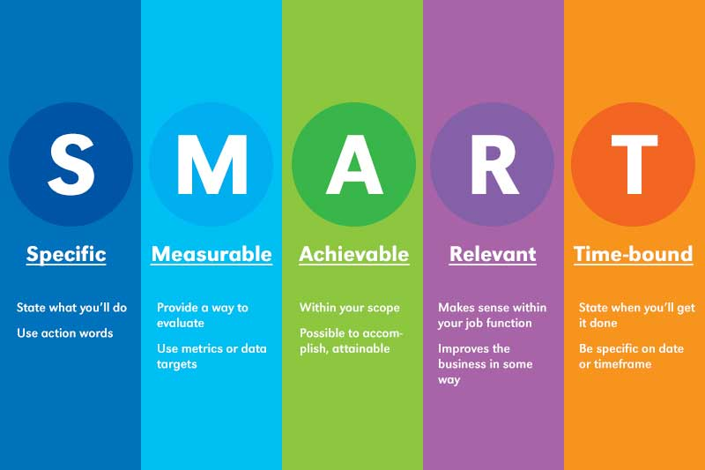

We would suggest that you develop 3-4 objectives for the next 6-8 months.
It would also be beneficial to your own learning and context for you to discuss your action plan with colleagues who might be able to support or contribute.

Objective  What would you  like to achieve or implement? | Task/s  What do you  need to do? | Success Criteria  What will it look like  if you achieve your objective? | Timescale  When would you like to achieve this?
e.g. Create an environment in which Safeguarding is not feared but spoken about openly, beyond process and policy | e.g. Safeguarding is discussed at PCC beyond reporting. | e.g. Discussions surrounding safeguarding in PCC’s are not a tick box but an open dialogue, in which we can explore how to create a safe space. | e.g. 6 months

Your self-reflection and action plan should be submitted to the pathway facilitators for review:
training.safeguarding@bathwells.anglican.org

Key relevant texts

Oakley & Humphries (2019) Escaping the Maze of Spiritual Abuse. Creating Healthy Christian Cultures. SPCK Publishing. https://spckpublishing.co.uk/escaping-the-maze-of-spiritual-abuse
Fife, Janet and Gilo (2019), Letters to a Broken Church. Ekklesia.
Harper and Wilson (2019) To Heal and Not to Hurt: A fresh approach to safeguarding in Church, Darton, Longman and Todd
Merchant (2020), Broken by Fear, Anchored in Hope: Faithfulness in an age of anxiety. SPCK Publishing. https://spckpublishing.co.uk/broken-by-fear-anchored-in-hope
Frankl, Viktor (2004) Man's Search for Meaning: The classic tribute to hope from the Holocaust, Rider
Atkinson (2014), Struggling to Forgive: Moving on From Trauma, Monarch Books

Atkinson (2006), Breaking the Chains of Abuse: A Practical Guide, Lion Books

Gardiner (2021), Sex, Power, Control: Responding to Abuse in the Institutional Church, www.lutterworth.com

Honeysett (2022), Powerful Leaders: When Church Leadership Goes Wrong and How to Prevent It, www.thegoodbook.co.uk

Graystone (2021) Bleeding for Jesus, Darton, Longman and Todd
www.dartonlongmantodd.co.uk

MacFarlane (2021) Going Public: A survivor’s journey from grief to action
Going Public a Survivor's Journey from Grief to Action by Julie Macfarlane - Paperback / softback - 9781771134750 (hymnsam.co.uk)

The Independent Inquiry into Child Sexual Abuse, Report on The Anglican Church
The Anglican Church: Safeguarding in the Church of England and the Church in Wales (iicsa.org.uk)

The National Report on Past Cases Review 2
Past Cases Review 2 - National Report.pdf (churchofengland.org)

The SCIE overview report
SCIE Final overview report of the independent diocesan safeguarding audits and additional work on improving responses to survivors of abuse.pdf (churchofengland.org)

The Church of England’s safeguarding policies
https://www.churchofengland.org/safeguarding/promoting-safer-church/policy-practice-guidance

Websites

www.nspcc.org.uk (National Society for the prevention of cruelty to children)
www.womensaid.org.uk (Female domestic abuse charity)
www.restoredrelationships.org (Christian domestic abuse charity)
www.mankind.org.uk (Male domestic abuse charity)
www.stopitnow.org.uk (child safeguarding organization)
www.scie.org.uk (Social Care Institute for Excellence)
www.ceop.police.uk (child exploitation and online protection command)
www.wearehourglass.org (adult safeguarding charity)
www.ageuk.org.uk (adult safeguarding charity)
www.barnardos.org.uk (child protection charity)
www.theclewerinitiative.org (modern slavery charity)
www.modernslavery.co.uk (modern slavery charity)
www.macsas.org.uk (survivor advocacy charity)
https://houseofsurvivors.org/
https://survivingchurch.org/

Helplines for further support
- Safe Spaces
Safe Spaces is for anyone who feels they have experienced church related abuse of any form in England or Wales. Safe Spaces comprises a team of trained support advocates who have undergone specialist training in supporting survivors of sexual violence and who have received additional specific training in how the churches respond to abuse cases, the way in which faith and church-related settings have been used to carry out abuse, and the issues affecting people who have had or still have, a relationship with the church.
You can contact the Safe Spaces team by: -
Tel: 0300 303 1056
(Answerphone available outside of opening times)
Email: safespaces@firstlight.org.uk
A live chat service is also available through the Safe Spaces website - Safe Spaces England and Wales – Safe Spaces England and Wales
The Safe Spaces team are available through their helpline and live chat service on:
Opening Times: Monday - Friday: 9am-9pm Saturday: 9am-1pm Sunday: 1pm-5pm

- NSPCC - For adults concerned about a child 0808 800 5000
- ChildLine - For children and young people on 0800 1111
- Action on Elder Abuse helpline 0808 808 8141
- 24-hour National Domestic Violence Helpline 0808 2000 247
- NAPAC – Offer support and advice to adult survivors of childhood abuse 0808 801 0331
- Stop It Now – preventing child sexual abuse 0808 1000 900
- Cruse – bereavement helpline 0808 808 1677

A ‘Church officer’ is anyone appointed/elected by or on behalf of the Church to a post or role, whether they are ordained or lay, paid or unpaid.
The exact wording of the Church's safeguarding standards is still draft, awaiting approval by the National Safeguarding Steering Group in May 2023, but the five standard areas will be the same.
https://www.churchofengland.org/sites/default/files/2021-07/code-of-safer-working-practice-02.07.2021.pdf
https://www.churchofengland.org/resources/clergy-resources/guidelines-professional-conduct-clergy/guidelines
https://safeguardingtraining.cofeportal.org/pluginfile.php/250612/mod_folder/content/0/Social%20GGRRAAACCEEESSS%20and%20Safeguarding.pdf
https://safeguardingtraining.cofeportal.org/pluginfile.php/250612/mod_folder/content/0/Social%20GGRRAAACCEEESSS%20and%20Safeguarding%20Easier%20read.pdf

