 | Global Christianity Resources
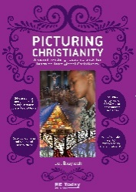 | Picturing Christianity  https://www.retoday.org.uk/school-support/publications/samples/picturing-christianity/  £42 | This fresh approach to learning from Christianity provides 24 beautiful images and works of art carefully chosen from global Christian sources
 | Understanding Christianity  https://www.understandingchristianity.org.uk/  Many schools have purchased this resource as part of their RE teaching on Christianity. The units on Incarnation and Salvation are particularly useful for teaching about global Christianity. | The key purpose of this project is to help all teachers support pupils in developing their own thinking and their understanding of Christianity, as a contribution to their understanding of the world and their own experience within it.
 | Compassion Charity  https://www.compassionuk.org/blogs/christmas-traditions-around-the-world/  These images could be used to promote questions. | If your school sponsors a child through Compassion, or another organisation, you may be able to find out about their Easter and Christmas experiences.
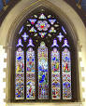 | Christianity through Stained Glass  https://www.natre.org.uk/uploads/Member%20Resources/Home%20learning/Updated/F2%207-11%20RE%20Today%20and%20NATRE%20home%20learning%20mem%20stained%20glass%20windows.pdf  https://galeriemagazine.com/7-jaw-dropping-stained-glass-windows/ | This may be a way into exploring the similarities of Christian art around the world.
 | Global Explorers and Global Neighbours  https://www.christianaid.org.uk/get-involved/schools/global-explorers  https://www.christianaid.org.uk/get-involved/schools/global-neighbours/about-accreditation-scheme  These two Christian Aid tools are not directly about global Christianity, but about being active globally and having a Christian perspective. | Global Explorers is an interactive teaching resource that will stimulate thinking about global issues.  Global Neighbours is a tool that can support a school with courageous advocacy, but is also about active Christianity.
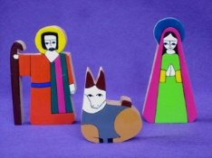 | Posada Nativity Tradition  http://spiritualchild.co.uk/posada.html | This is a great activity to do as a class, school or church at Christmas.
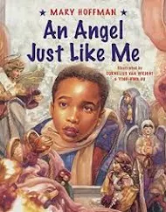 | An Angel Just Like Me  https://ldbs.co.uk/wp-content/uploads/2021/11/An-Angel-Just-Like-Me-Project-Booklet-Christmas-2021-converted-compressed-2.pdf | An Angel Just Like Me was written nearly twenty five years ago, but is still as relevant today. It is the story of African American boy Tyler’s search for an angel that looks like him to put on the family Christmas tree. This makes a great prompt for encouraging children to think about the stereotypes and assumptions they make about the Christmas story and about the wider world they live in.
AMV Unit | Christianity Around the World  https://www.amvsomerset.org.uk/wp-content/uploads/2016/06/Lower-KS2-Unit-4-Lesson-10-Christianity-Around-the-World.pdf | This unit has some ideas that may inspire some starting points for you.
 | Zambia link through Bath and Wells Diocese  https://www.bathandwells.org.uk/faith/world-mission-and-zambia-partnership/zambia-partnership/ | If your school or parish has a link with Zambia, you could find out what church is like for children, families and adults.
Other possible resources: | - BBC Songs of Praise recordings  - Christmas or Easter artefacts  - Christmas around the world  - Easter around the world  - Research about Christian countries – each group of children find out 3 interesting facts.  - The Lord’s Prayer https://www.youtube.com/watch?v=bG8XuJXQpRQ  - The Blessing Song https://www.youtube.com/watch?v=d48-qbcovVY  - Investigating the similarities and differences between Anglican and Catholic Christian practice.

Please let us know if you find some helpful ways of developing children’s awareness of being a Christian in different parts of our world.

